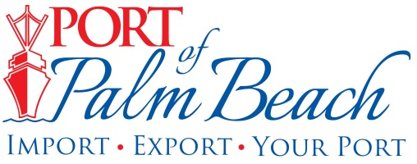
Media Contact
Yaremi Farinas
yfarinas@portofpalmbeach.com
OFFICE: 561-383-4138
CELL: 561-319-0098

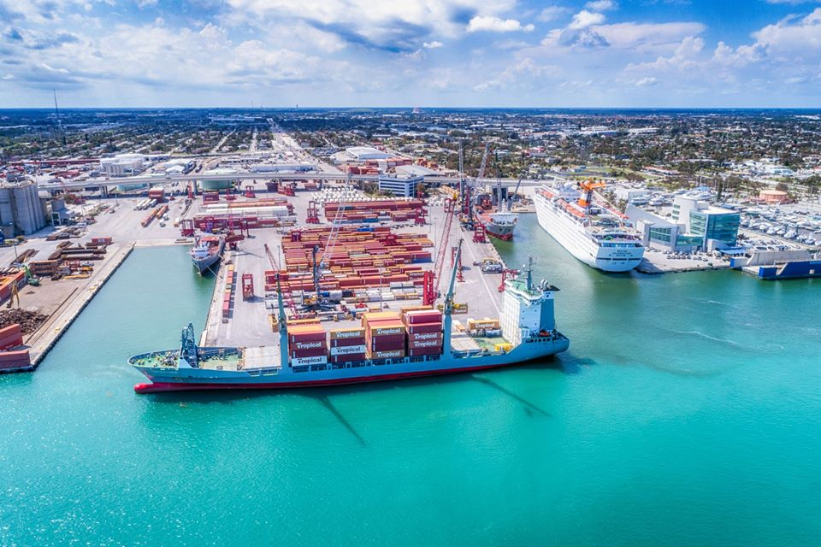

Port of Palm Beach commemorates 5th Annual ‘Ports Day’ on April 5th

2020 event recognizes value of Western Hemisphere seaports to COVID-19 response and recovery, supply chain continuity and long-term economic stability
Riviera Beach, Florida, April 4, 2020 – The Port of Palm Beach joins the American Association of Port Authorities (AAPA) in commemorating the fifth annual “Western Hemisphere Ports Day” on April 5th.
In years past, the event recognizes the port industry’s role in efficient goods movement, job creation and propelling the economy in nations they serve across the Americas.
This year’s event will focus on the role of ports in the COVID-19 pandemic response and recovery. It’s a recognition of the dedication, sacrifice and professionalism of the port industry workforce in their collective efforts to slow the spread of coronavirus while ensuring a steady flow of vital goods and services.
“Our tenants and their employees are the reasons commerce continues to move through the Port of Palm Beach during the COVID-19 pandemic. Port of Palm Beach Board of Commissioners and I, thank them for their continuous hard work and dedication during these difficult times. It’s because of our tenants that people living in the Caribbean still have the ability to purchase food, medical supplies and other goods in the islands,” said Executive Director Manuel Almira.

In the U.S. alone, more than 652,000 maritime-industry professionals work every day to ensure that cargo and cruise and ferry travelers move efficiently through the nation’s ports. Through passenger and crew screenings, vessel quarantines and other measures, seaports are committed to ‘flattening the curve,’ both domestically and among their country’s critical trade partners around the world.
“In this time of uncertainty and fear about what to expect next, port workers and their logistics partners are laboring around the clock to keep vital consumer goods, medical supplies, energy and raw materials moving,” said Chris Connor, AAPA president and CEO.
“While taking all necessary precautions against spreading the virus themselves, our maritime workforce continues to deliver vital goods and services, ship exports, and connect farmers, manufacturers, retailers and consumers to the global marketplace. As families, businesses and communities begin to recover from the crisis we’re all facing, our member ports are ready to deliver the products you need and want, keep your shopping cart filled, and take whatever actions are needed to support a strong, stable economy,” Connor said.
According to IHS Markit’s GTA Forecasting (previously known as IHS World Trade Service), combined international sea trade moving through Western Hemisphere seaports in 2018 totaled nearly 4.2 billion metric tons in volume and US$3.7 trillion in value. Of that combined total, seaports in Central and South America handled 1.86 billion metric tons of cargo valued at US$1.17 trillion, while North American seaports handled 2.34 billion metric tons of goods, valued at US$2.53 trillion.

About Port of Palm Beach
Located in Riviera Beach, the Port of Palm Beach is a full-service, diversified port, offering cruise and cargo services to more than 30 onsite tenants and users. At 162 acres, the Port’s efficiency is unparalleled, processing more than $7 billion in commodities, 2.5 million tons of cargo, and 500,000 cruise passengers annually. As one of the largest employers in Palm Beach County, the Port of Palm Beach and its tenants employ more than 2,850 people. Through the contribution of more than $185 million in business revenue and $17.5 million in tenant-contributed state and local annual tax revenue, the Port of Palm Beach is a large economic engine in South Florida. For more information, visit www.portofpalmbeach.com.

